Subject Selection Resources
  - Year 10s planning for Year 11.

Check recommended subjects
- Login to JobJump at https://www.jobjump.com.au/ (or create a new account using school password: goat)
- Go to the menu item Subjects on the top.
- Select the Careers you like and a box will appear with good advice and questions to consider. In bold type will be certain HSC subjects that may provide help towards your future.
Here is a quick video that gives you guidance:
https://jobjump.com.au/helpVideo?video=subjectSelection

Career Quiz
If you are still unsure what careers you’re interested in, you can complete a career quiz here: https://www.skillsroad.com.au/my-account/my-careers-quiz
Your results will include a list of careers that you can then explore

Guide to Australian careers
For information on career overviews, future prospects, pathways, skills and knowledge and work environments, you can check out: https://joboutlook.gov.au/

Are you thinking of going to University?
You can also watch this quick video: https://jobjump.com.au/helpVideo?video=myAtar
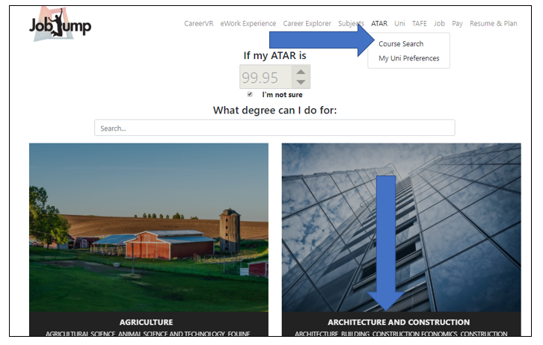
- Click on the menu option ATAR and then select Course Search.
- Enter the ATAR you hope to achieve or click I’m not sure.
- Pick your favourite category (like Architecture, Education, Engineering).
- Now click Show HSC Subjects. Underneath each course is the HSC advice you need.
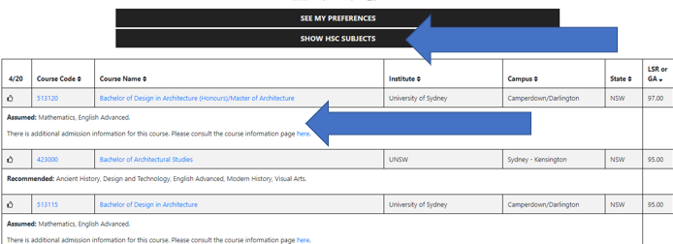
Always check for course:
- Prerequisites
These are HSC courses you have to have studied before a university will offer you a place in their course.
- Assumed knowledge
These are HSC courses the university assumes you have studied before you start the university course. Not a requirement for entry, but without the assumed knowledge you may have difficulties coping with your university studies.
- Recommended studies
These are HSC courses the university suggests will prepare you for core first year university courses. Not a requirement for entry.

